Northern Golden Retriever Association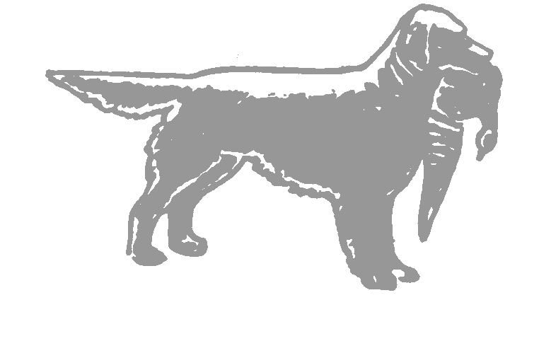Est. 1946
www.northerngoldenretriever.org.uk
Treasurer  Mr John Newsham  1 Brazenhill Lane  Haughton,  Stafford.  ST18 9HS  01785 780149 | Chairman:  Mr Steven Crookes  President :  Mr A M Hickinbottom | General Secretary  Mr Philip Smithies  52 Hollin Lane  Middleton  Manchester  M24 5EE  0161 653 3050  philip.smithies1@btinternet.com
Show Secretary  Miss Angela Aulton  Littleworth House Farm  Alkmonton  Ashbourne  Derbyshire.  DE6 3DG  01335 330660 |  | Field Trial Secretary  Mr Steve Crookes  Moscar Grange Cottage  Hollow Meadows  Sheffield  S6 6GL  0114 230 1436  crookes.moscargrange@googlemail.com
3 July, 2021
Dear Philip
In appreciation of your 30 year commitment as Field Trial Secretary of the Northern Golden Retriever Association and your recent retirement from the post, the Association would like to invite you and Anna, as their guests, to the 2 day Field Trial at Hy-Fly on Monday 11 and Tuesday 12 October, 2021. Accommodation has been booked for yourself and Anna at Guys Thatched Hamlet for the Sunday and Monday nights. You are both also invited to the Field Trial dinner on the Monday evening.

Steve Crookes
(Chairman)

